Line Tracking Sensor for Arduino (SKU:SEN0017)

## 42-103.jpgIntroduction

The [DFRobot Line Tracking Sensor for Arduino](https://www.dfrobot.com/product-85.html) can detect the white lines in black and black lines in white. The single line-tracking signals can provide a stable output signals TTL, so look for more accurate and more stable line. Optional multi-channel mix is easy to install with the necessary line-tracking robot sensors.

## Features

* Power supply: +5V
* Operating current: <10mA
* Operating temperature range: 0°C ~ + 50°C
* Output interface: 3-wire interface (1 - signal, 2 - power, 3 - power supply negative)
* Output Level: TTL level (black line of low effective, high efficient white line)
* Module Size: 10mm×35mm
* Module Weight: About 1g

## Installation

The best distance between objects such as ground and the sensor is 1-2 cm.

## Connection Diagram

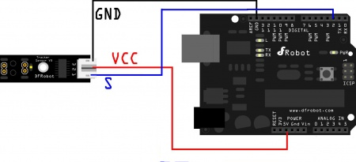

## Sample Code

void setup()

{

Serial.begin(9600);

}

void loop()

{

Serial.println(digitalRead(2)); *// print the data from the sensor*

delay(500);

}

|  |  |  |  |  |  |  |  |  |  |  |  |  |  |  |
| --- | --- | --- | --- | --- | --- | --- | --- | --- | --- | --- | --- | --- | --- | --- |
| |  |  | | --- | --- | | SKUSEN0017 | SKU | | Match, Like | No Data | No Data | | Start with | No Data | [SKU*](http://www.alldatasheet.com/view.jsp?Searchword=SKU&sField=2)(17) [SKUT](http://www.alldatasheet.com/view.jsp?Searchword=SKUT&sField=2)*(17) | | End | No Data | *[-SKU](http://www.alldatasheet.com/view.jsp?Searchword=-SKU&sField=3)(1) | | Included | No Data | *[SKU](http://www.alldatasheet.com/view.jsp?Searchword=SKU&sField=1)*(66) *[SKU1](http://www.alldatasheet.com/view.jsp?Searchword=SKU1&sField=1)*(15) *[SKU4](http://www.alldatasheet.com/view.jsp?Searchword=SKU4&sField=1)*(1) *[SKU5](http://www.alldatasheet.com/view.jsp?Searchword=SKU5&sField=1)*(1) *[SKU7](http://www.alldatasheet.com/view.jsp?Searchword=SKU7&sField=1)*(6) *[SKU9](http://www.alldatasheet.com/view.jsp?Searchword=SKU9&sField=1)*(6) *[SKUV](http://www.alldatasheet.com/view.jsp?Searchword=SKUV&sField=1)*(2) | |
| |  |  | | --- | --- | | **Manufacturer** | **ALL** SEMIKRON(17) | |

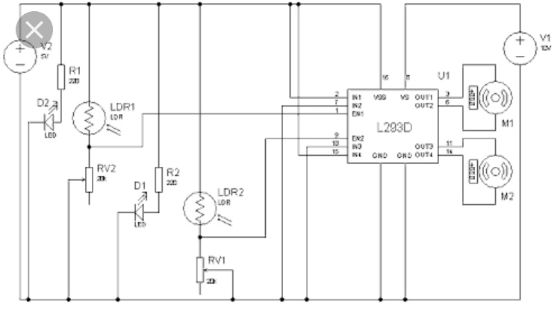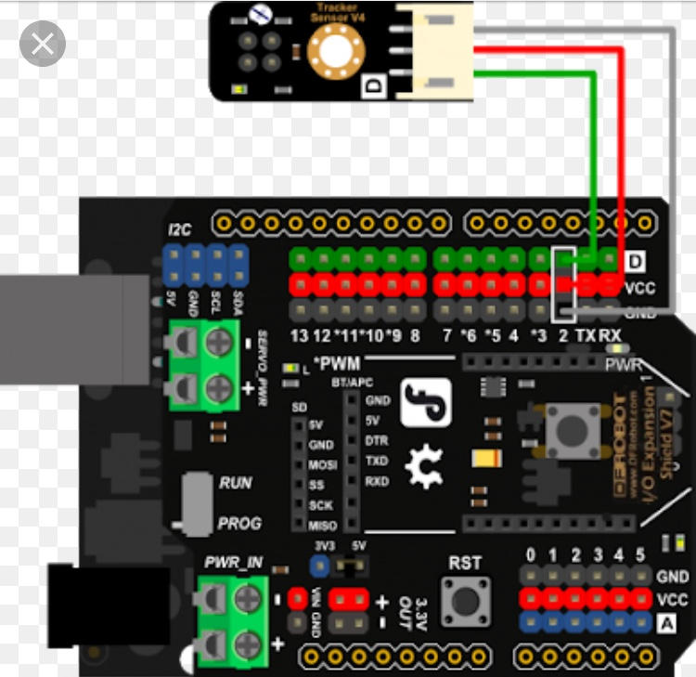

<https://youtu.be/1LJsVrzxIcQ> video: